VISVESVARAYA TECHNOLOGICAL UNIVERSITY,
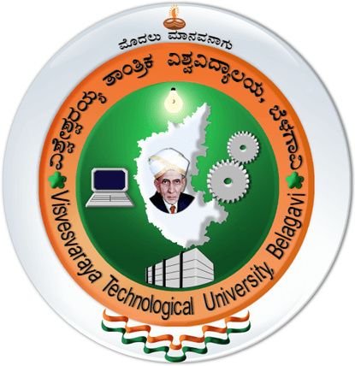
JNANA SANGAMA, BELAGAVI, KARNATAKA
A Project Report On
“INSTANT HOME SERVICE SYSTEM”
Interdisciplinary Project Work (1BPRJ258)
Submitted in partial fulfillment of the requirements for the award of the Degree
BACHAELOR OF TECHNOLOGY

SUBMITTED BY

Roll No | Name of the Student | Dept | USN
134 | Apoorva P Bangari | ISE | 2BL25IS008
148 | Raghavendra B Patil | ISE | 2BL25IS022
159 | Samruddha Kadiwal | ISE | 2BL25IS034
174 | Tejaswini B Biradar | ISE | 2BL25IS049
177 | Vishal Kavishetty | ISE | 2BL25IS052
399 | Girish S Nandur | CIVIL | 2BL25CV021

UNDER THE GUIDANCE OF
Prof. S.M.Chadchan
Associate Professor, Department Of ISE



DEPARTMENT OF ISE

B.L.D.E. Association’s
VACHANA PITAMAHA DR. P.G. HALAKATTI COLLEGE OF ENGINEERING AND TECHNOLOGY,
VIJAYAPUR – 586103

2025-2026

